India is the fastest-growing games market in Asia, both in terms of revenue and gamers, we have around 450 million gamers in India. Video games are not just entertainment; they enhance concentration, creativity, memory, language skills, and teamwork, making them effective educational tools as well.
From grassroots to big budgets, the journey of Indus Battle Royal is one for the textbooks. Indus is inspired by Indian culture and mythology, and features the Indus Valley Civilization as the theme. Indus Battle Royale is a futuristic battle royale game set in an ancient Indian-inspired world.
The game is set in an Indo-Futuristic Battle Royale featuring a next-gen tactical battle royale experience, a never-before-seen Grudge feature, a unique Cosmium win condition, groundbreaking Avatars, deep lore, immersive graphics and a real-time multiplayer game with 60 players is an elaborate Rube Goldberg machine with different components and intricacies.
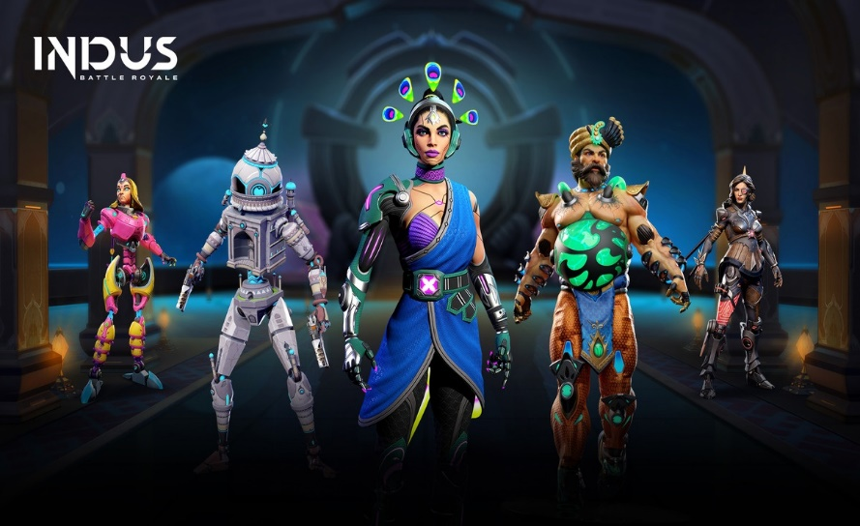
Indo-Futurism as a concept in-game is seen as unique yet relatable. This is due to the game’s unique characters, such as Jatayu and Sir-Taj, often relatable yet exciting representations through Indo-Futurism. With immersive graphics and real-time multiplayer capabilities, players can enjoy a dynamic experience enhanced by gestures for character control, eliminating the need for traditional controllers.
Players can engage in real-time multiplayer matches with up to 60 participants, using gesture controls that allow them to navigate and perform actions through facial movements-no traditional controllers needed. This creates a seamless gaming experience that feels intuitive and immersive.
Indus is more than just a game; it aims to authentically showcase Indian culture and artistry, addressing the limitations of previous international attempts to represent Indian themes. With its bold vision, Indus Battle Royale not only celebrates India's rich heritage but also offers a futuristic narrative that resonates with a global audience. As the gaming industry continues to grow, titles like Indus are paving the way for India's cultural expression in the digital realm.

